* **Latitude Vs Temperature:**

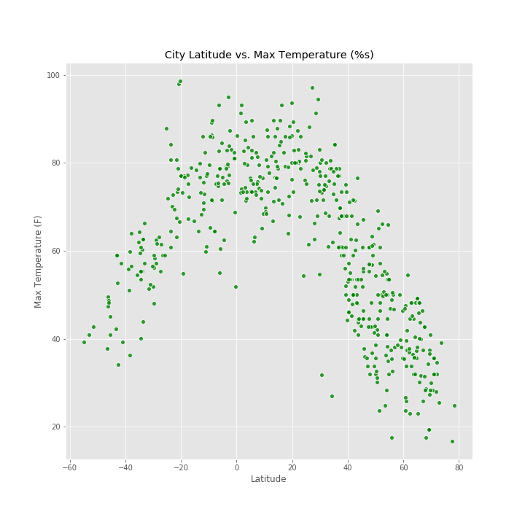

There is a relationship between latitude and temperature around the world, as temperatures are typically warmer approaching the Equator and cooler approaching the Poles.

* **Latitude Vs. Humidity:**

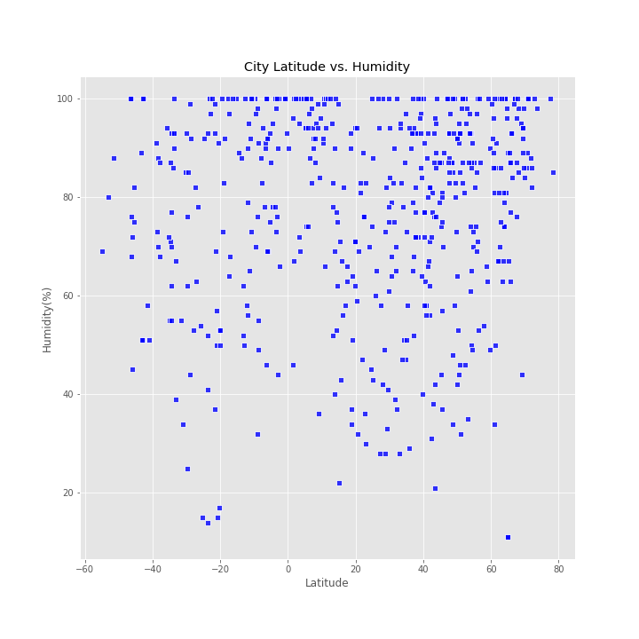

Humidity changes when temperatures change. Because warm air can hold more water vapor than cool air, relative humidity falls when the temperature rises if no moisture is added to the air. As we know from the first graph that temperatures are typically warmer approaching the Equator and cooler approaching the Poles so the humidity higher in the places near Equator and lesser towards Poles.

* **Latitude Vs. Cloudiness:**

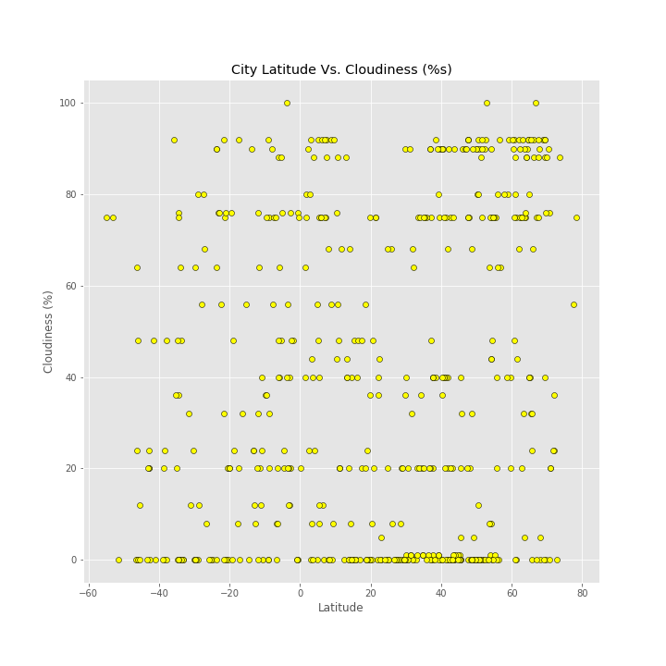

Cities with latitude nearer to the Equator is cloudy compare to others but places above latitude 60 degree is higher in cloudiness.

* **Latitude Vs. Wind Speed:**

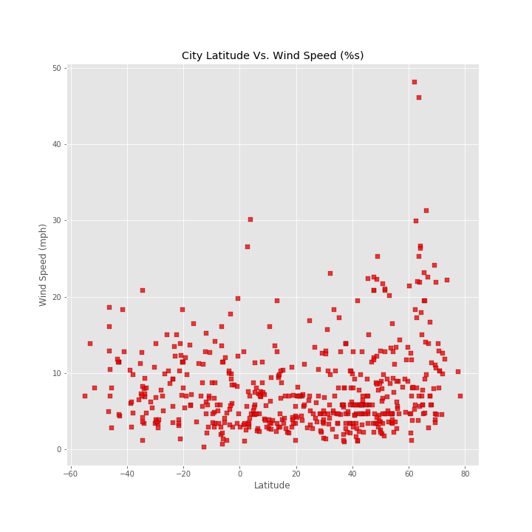

Cities nearer to equator is higher in temperature and in matter of wind speed , those particular places are not as high as poles.